**ME3023 Challenge 4 Background**

**Information:**

* Handheld oscilloscope and power supply module introduction video links
* Resistor Chart and Capacitors Codes
* Breadboards and some simple wiring layouts
* Series and Parallel Resistor Formulas
* Wheatstone Bridge Formulas

**Some History**: While analog devices have been supplanted by their digital equivalents in many applications, they are still widely used and remain engrained in engineered devices. An analog output format is often ergonomically superior in monitoring, as evidenced by modern car speedometer dials and dial wristwatches. Too often we qualify a digital device by its digital readout, but internal analog circuits form the foundation for both analog and many digital indicating systems. In fact, many of the systems that we interface with are analog and digital hybrids. Within a signal chain, it is common to find digital and analog electrical devices being used together and so requiring special signal conditioning. An understanding of analog device function provides insight, as well as a historical reference point, into the advantages and disadvantages of digital counterparts.

**Handheld Oscilloscope Video:**

<https://www.youtube.com/watch?v=EA1v2LcCgro>

**Power Supply Module Video:**

<https://www.youtube.com/watch?v=i9l51qYtpJM>

**Capacitors (passive electrical elements)**

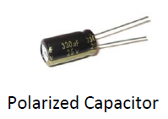 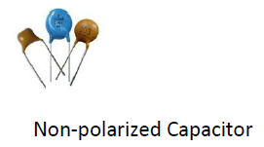

Capacitor Codes

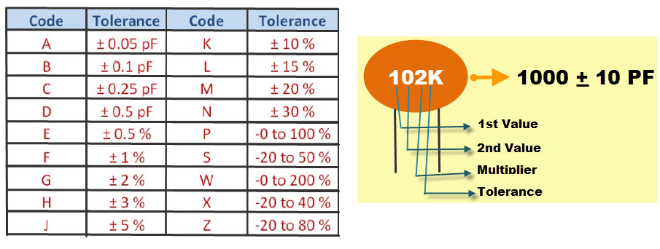

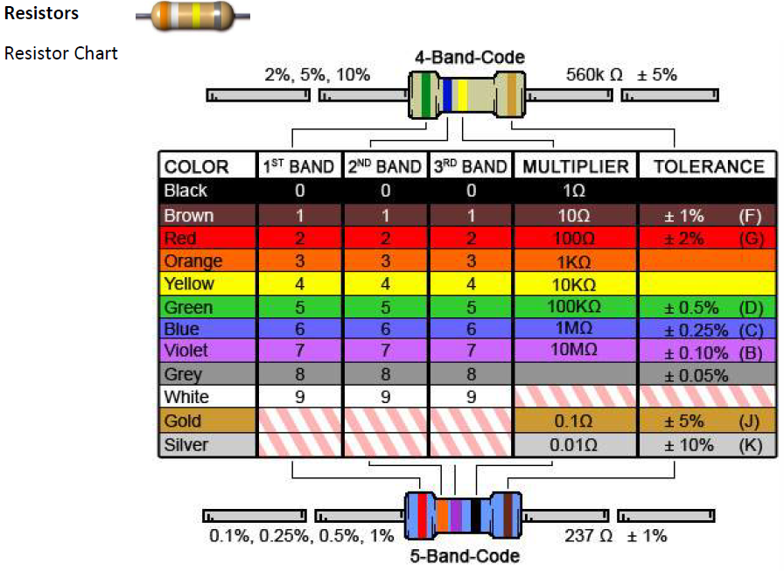

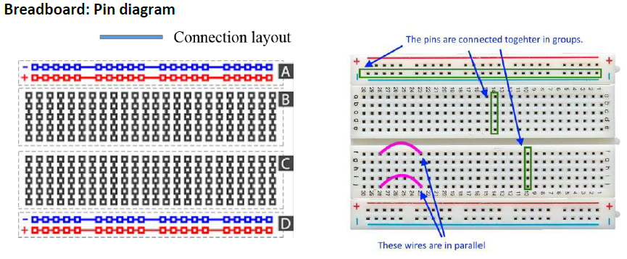

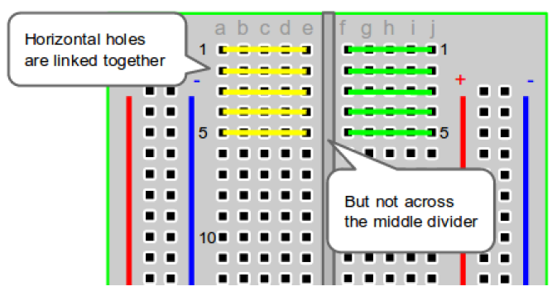

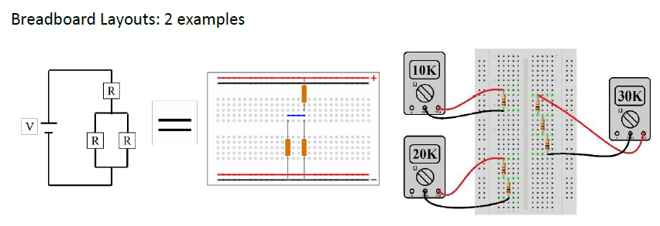

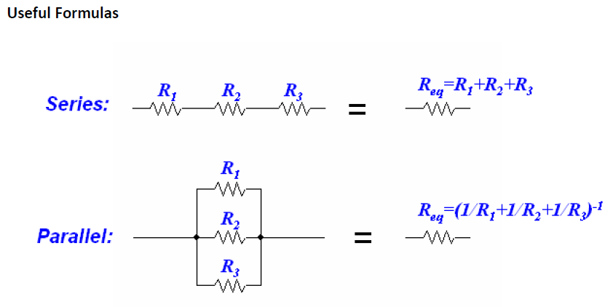

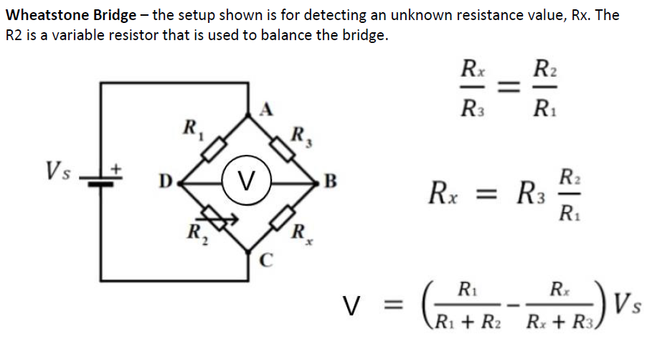

**Useful links for more information (Circuit)**

Voltage Dividers

<https://learn.sparkfun.com/tutorials/voltage-dividers/all>

Wheatstone Bridge

<https://www.electronics-tutorials.ws/blog/wheatstone-bridge.html>

<https://www.grc.nasa.gov/www/k-12/airplane/tunwheat.html>

Resistance

<https://opentextbc.ca/physicstestbook2/chapter/resistors-in-series-and-parallel/>

Capacitors

<https://www.wikihow.com/Read-a-Capacitor>

<https://learn.sparkfun.com/tutorials/polarity/all>